Annex 1 – Questions on Notice
The two photos below accompany Question TH8 from Cllr Sajjad Malik to Cllr Hayes – Pollution on Hollow Way:
What happens if pollution levels become consistently illegal on Hollow Way following the introduction of these measures. Because that's what started to happen in September and October.
Legal limit is 40. It was below on Hollow Way before the pandemic.

Photo 1
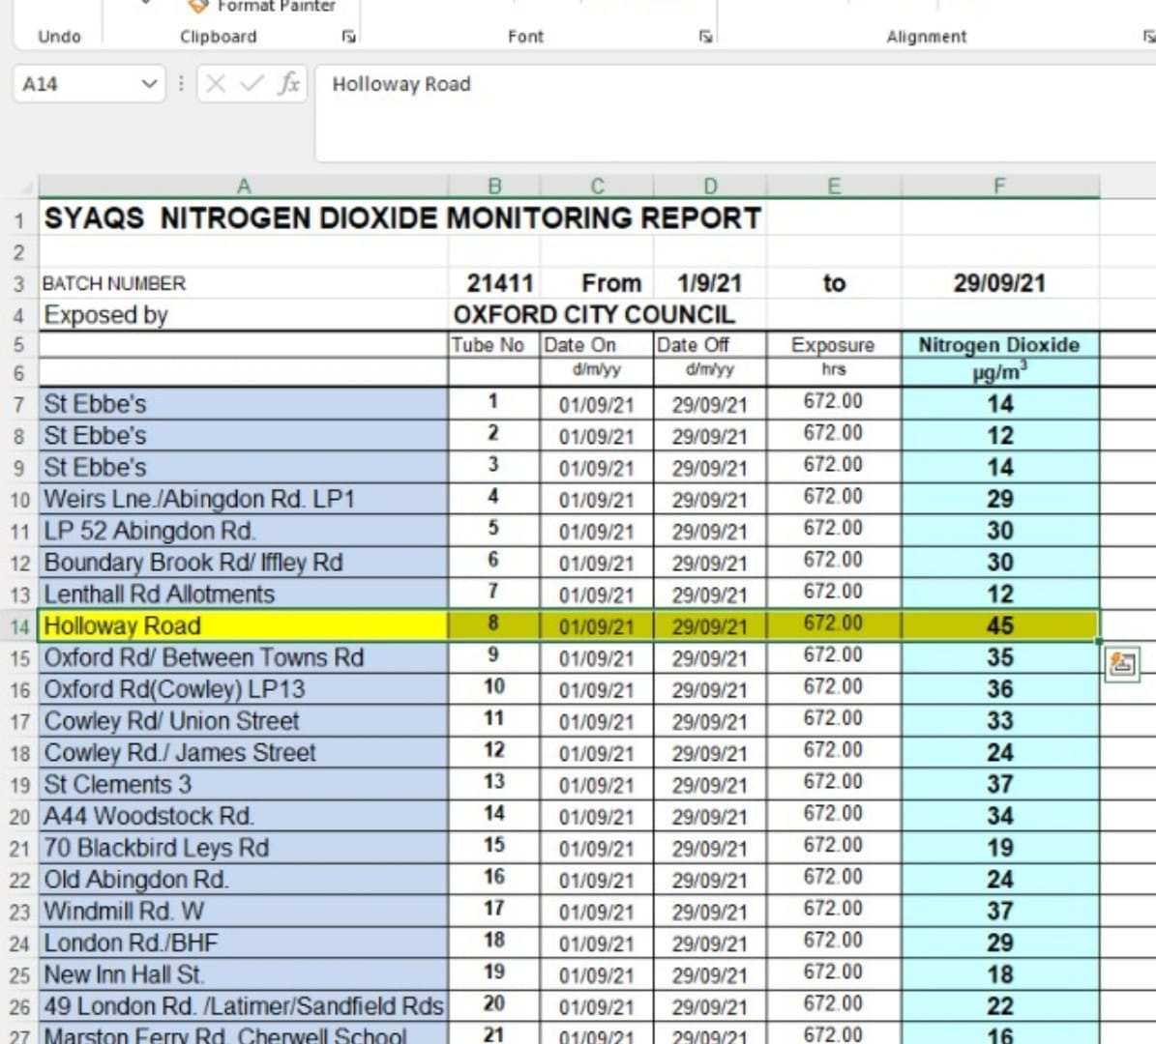

Photo 2
